# Running Validation Tests

Pneumvent is a well-integrated device that constantly compare all of the sensors and actuators data to each other ensuring that all parameters are within a predefined threshold. However, it is important to run validation tests often since having the device report a failure while running on a patient could be catastrophic as compared to verifying the device functionality beforehand.

This section describes how to run a validation test as well as the frequency of validation.

# How often should I run the validation test?

The validation test should run every time a component is removed/replaced from the device, this includes the HME, filter, battery, respiratory tube and anything that is considered part of Pneumvent.

This ensures that any of the components added such as breathing tube are not defective. For instance if the breathing tube has a leak/hole Pneumvent will be able to tell and throw an alarm condition.

# How do I run the validation test on Pneumvent?

Running the validation test is automated on Pneumvent and it is runs on a series of self-tests by the click of a set of buttons. However, during one of the self-tests conditions, Pneumvent will require the intervention of a user/technician to simulate the self-assisted operation. This is discussed below.

# Control Panel Preview

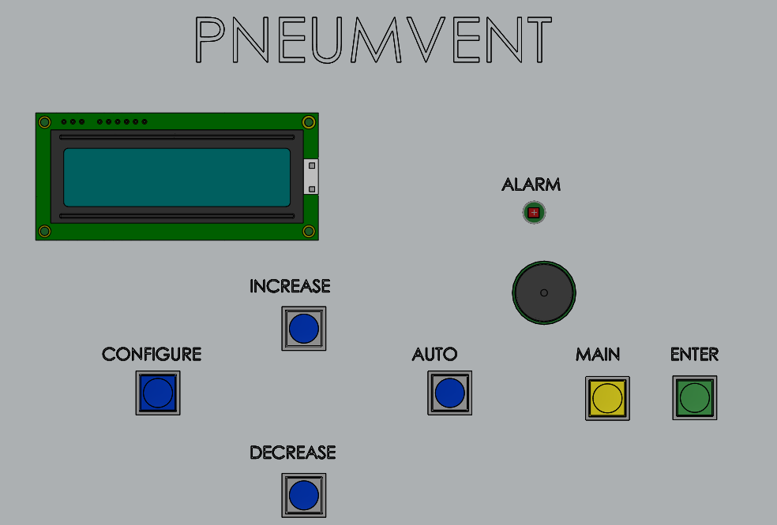

## Process:

1. Plug in Pneumvent into the main wall socket and ensure a “Beep” sounds for three seconds
2. Ensure the LCD displays “STAND-BY MODE”

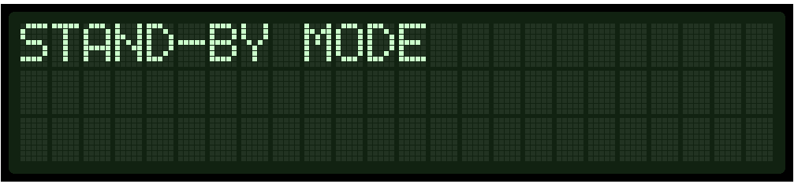

1. Next Press the “AUTO” button for 10 seconds
2. The device will display

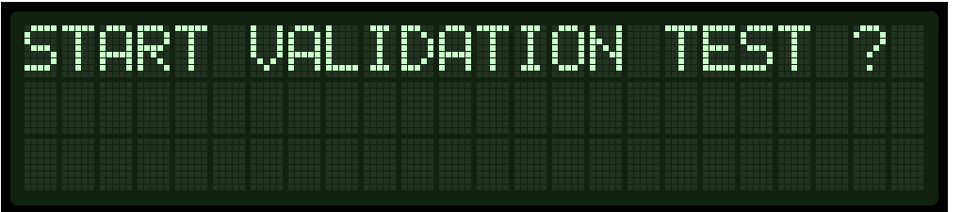

1. Press the “ENTER” button
2. The validation test will run as follows:

* Lung Pressure test

“PASS” will be displayed with a short beep, or “FAIL” with a constant beep

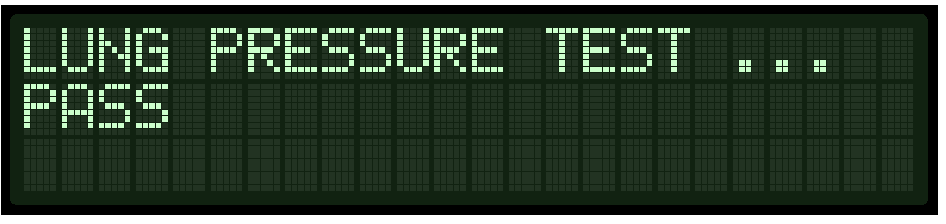

* Breathing Rate Test

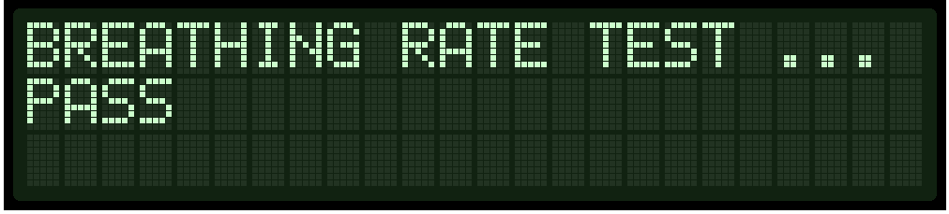“PASS” will be displayed with a short beep, or “FAIL” with a constant beep

* Inspiration/Expiration Ratio test (I:E test)

“PASS” will be displayed with a short beep, or “FAIL” with a constant beep

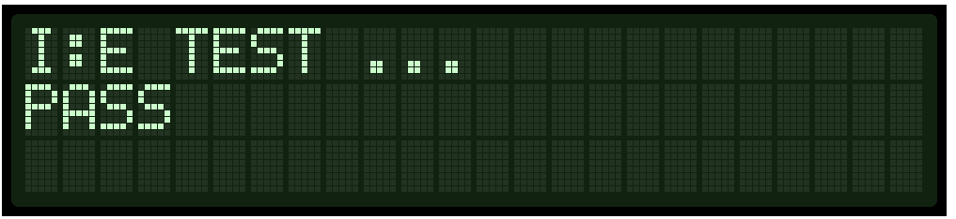

* Air Mixture Pressure Test

“PASS” will be displayed with a short beep, or “FAIL” with a constant beep

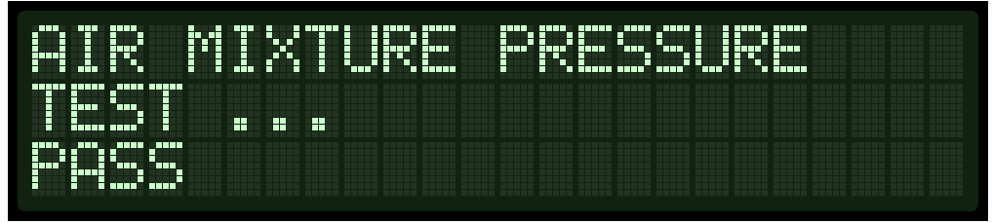

* The Operation mode of trigger will star running 5 seconds after the screen:

“PASS” will be displayed with a short beep, or “FAIL” with a constant beep

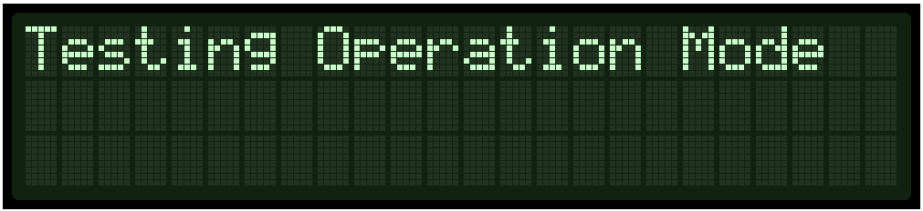

* Testing Pressure Triggered Mode:

“PASS” will be displayed with a short beep, or “FAIL” with a constant beep

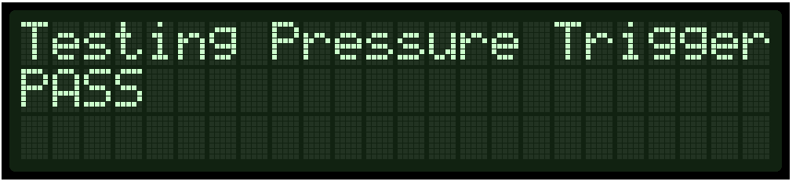

* Testing Time Triggered Mode:

“PASS” will be displayed with a short beep, or “FAIL” with a constant beep

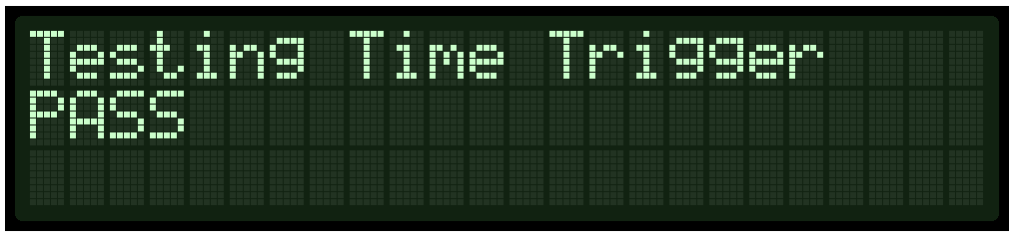

* Testing Assisted Pressure Mode, note in this mode user assistance is required:

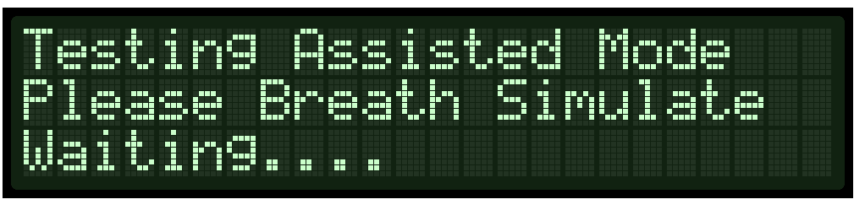

* After reaching this screen the user is required to simulate a breathing trigger by creating a vacuum on the breathing tubes. Once can achieve that by placing the palm of their hands on top of the tube opening creating a strong seal and quickly lifting their palm. As a result a suction pressure is simulated. The screen updates to :

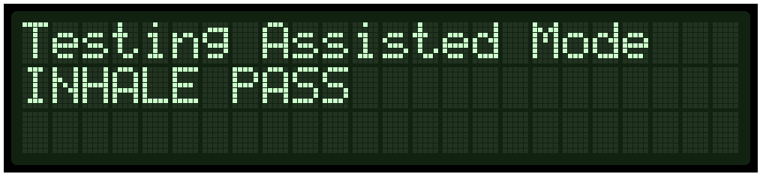

* Next create an exhalation simulation by doing the reverse with your palm and pushing air into the tube (or you can blow into the tube), the screen updates to:

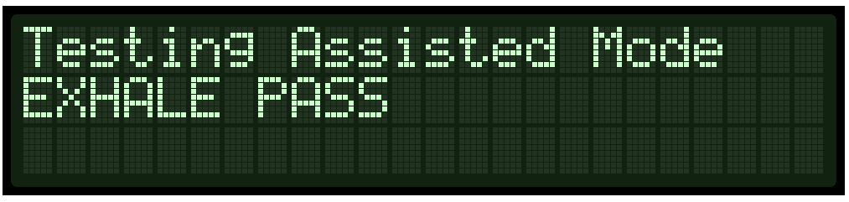

* The validation test is complete at this point and the screen updates to:

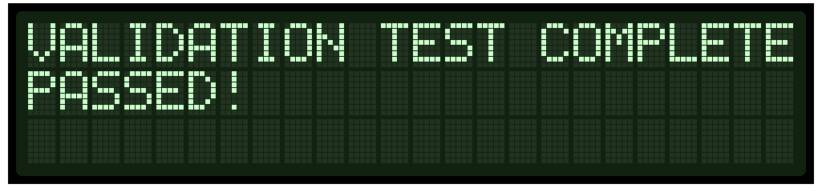

This means that the validation test is complete and the device is ready to use!